Documentation for IDGenerator

IDGenerator is the AWS Cloud based project which generates different Ids for applications like GuideWire, Surety, Arden and APS.

This document describes the various components of this project. This is followed by an explanation of how the main lambda function of this project works. I also includes the RDS schema that is being created for this project.

# Serverless component

Aws Aurora serverless v2 is an on-demand and autoscaling configuration database. It is highly scalable, cost-efficient, and highly available in different zones. Aurora serverless can start and stop the computation automatically as per requirement and also allocate storage memory efficiently.

Terraform script for Aurora serverless is shown below.

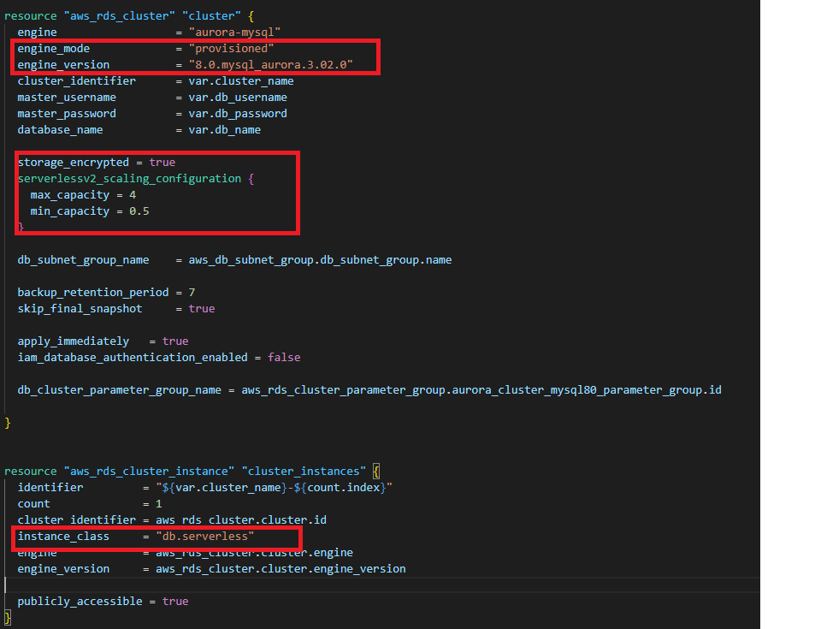

# Database Component

## AWS RDS

AWS RDS is a fully managed AWS database service. It provides cost-efficient, scalable, and manageable relational database. We are using AWS RDS Aurora serverless V2, which is available for Aurora MySQL edition.

# General Component

## AWS VPC

Amazon’s virtual private cloud allows creation of resources for the virtual network and we have complete control over virtual environment for creating subnets, configuration, route tables, and network gateway etc.

## AWS Lambda

AWS Lambda is a serverless computing service, it is used to create lambda functions, self-contained applications that can be written in a language supported by AWS. The execution of the lambda function is efficient and flexible. The lambda function can perform computation tasks, serve web pages, and integrate with other AWS services.

# How Lambda Function works

Lambda function is using 8 different methods like id_Generate, saveData, assignRange, getData, getDataParams, getDataById, invoke_lambda, and lambda_handler.

## id_Generate

This method generates Id as a sequence number for every application and stores that Id along with application name, sequence type, current date, current time and user information in the SequenceIds table.

## saveData

This method is used to check the Id which was generated most recently by the id_Generate method. If the Id is out of range then this method deletes that Id from the SequenceIds table. If within range it updates the Id in the SequenceIds table to keep track of the latest Id generated and to avoid exceeding Id range values.

## assignRange

This method is used to assign new sequence range for SequenceRange table and set status false to the previous range. This method always assigns greater range from the previous range.

## getData

This method gets only latest Id data for all applications from SequenceIds table and display that data in the browser.

## getDataParams

This method gets the most recent data for a single application from SequenceIds table and display that data in the browser.

## getDataById

This method gets data for a specific Id from SequenceIds table and display that data in the browser.

## invoke_lambda

This method is checked in the database that SequenceRange and SequenceIds tables exists or not if tables exists in RDS it simply gets all data from the table otherwise it will call another lambda function that will create a table in RDS and then provide parameters to the other methods that are mention above.

## lambda_handler

This is the main function of lambda function. It has all information of API request body and request details that is used to invoke lambda.

# How to Deploy the project

This Project is deployed by Terraform. Terraform is a tool for building, changing, and managing infrastructure in a safe, repeatable way. It is an infrastructure provisioning tool where you can store your cloud infrastructure setup as codes.

The following commands are used to deploy the project:

**$ terraform init**

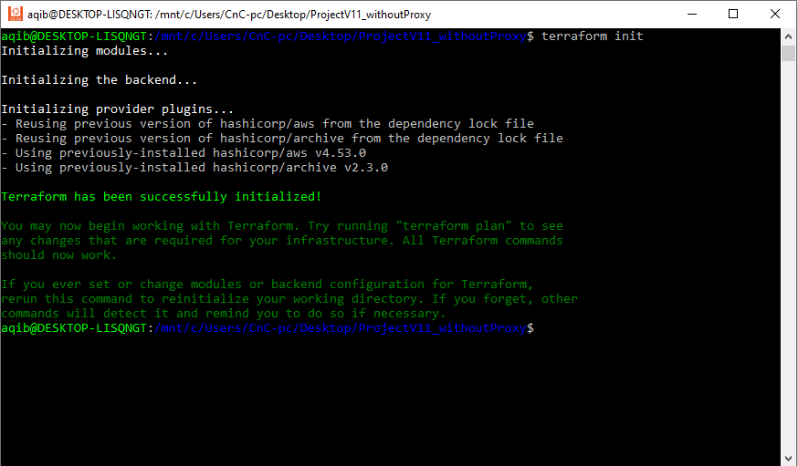

**$ terraform plan**

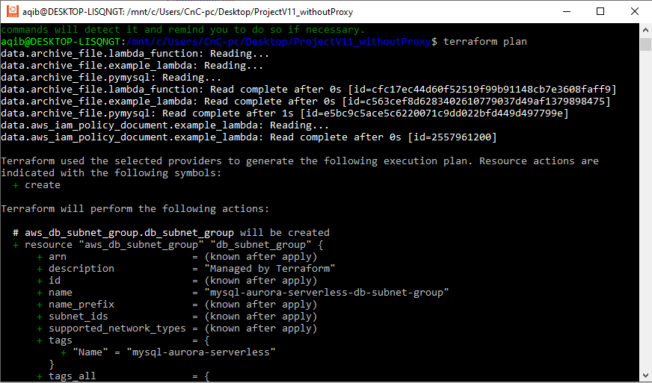

**$ terraform apply**

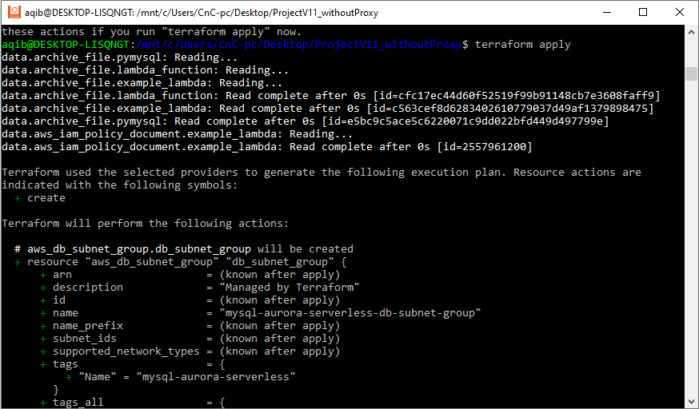

After "**terraform apply**" command completes, copy the Lambda function **url** and use it to call **GET** method through browser or Postman.

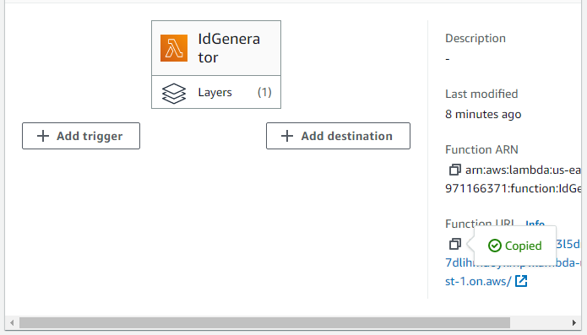

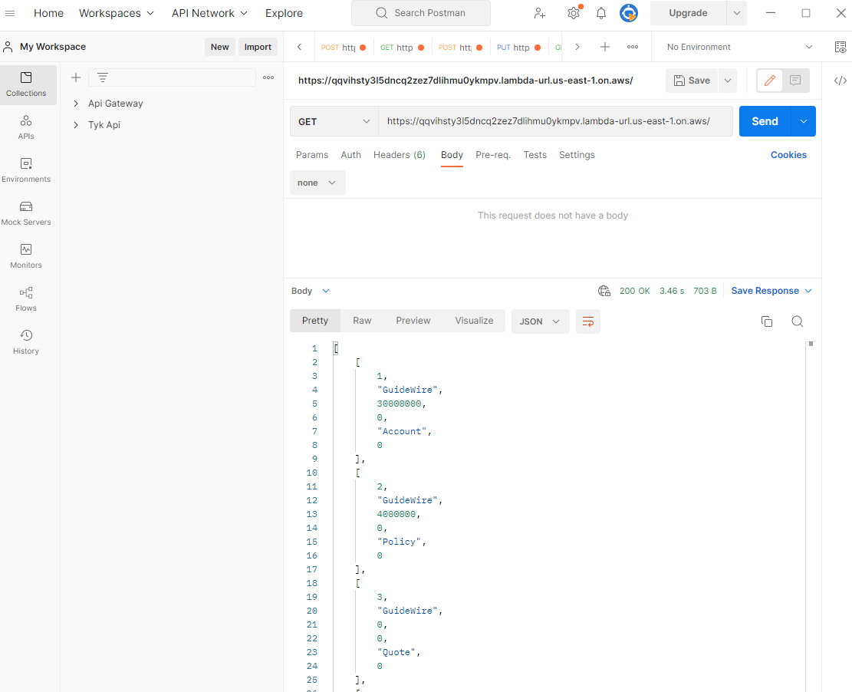

To get data from database based on the **Id, s**end a parametrized **GET** request. Url of the request looks like below:

**https://fogykt2ixwomumpk4en76d6roq0jwlrq.lambda-url.us-east-1.on.aws?Id=4000002&AppName=GuideWire&Type=Policy**

It returns detail of the Id for the AppName and Type provided (if it exists)

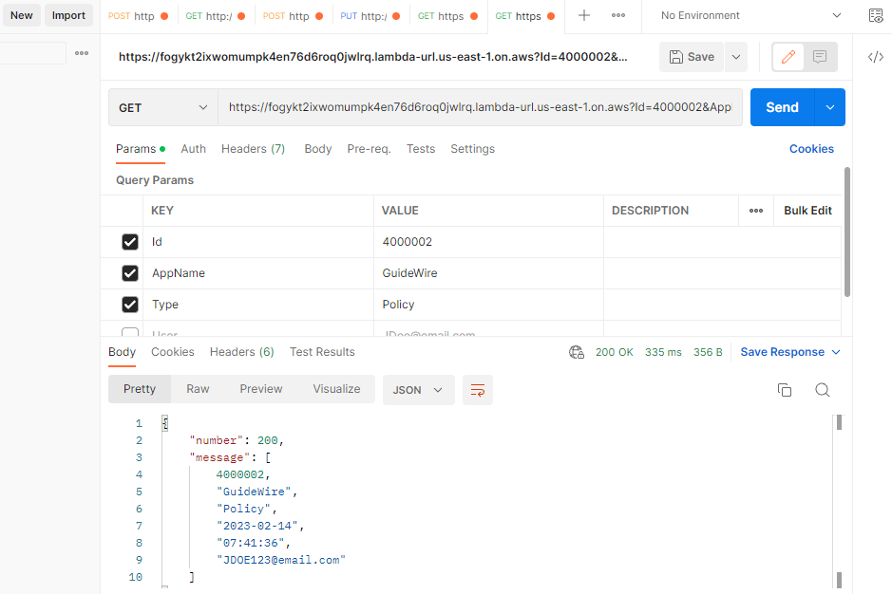

To get last record of any application from the database, send a parametrized **GET** request. Url of the request looks like below:

**https://fogykt2ixwomumpk4en76d6roq0jwlrq.lambda-url.us-east-1.on.aws?AppName=GuideWire&Type=Policy**

It returns audit detail of last Id generated for the provided AppName and Type.

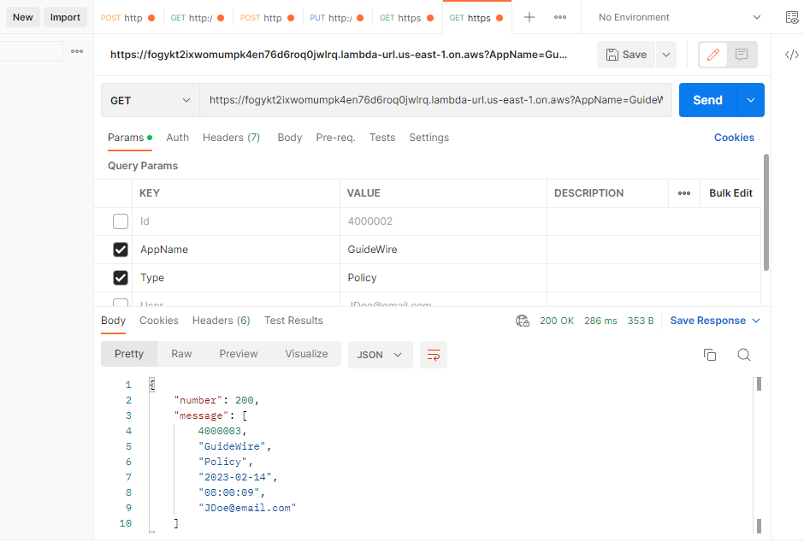

In the **POST** method of Lambda function, send parameters in JSON format.

Details of REST API parameters:

**AppName**: This is the application name e.g. **GuideWire**, **Surety**, **Arden** and **APS**.

**Type**: This is Id Type e.g. **Account**, **Policy** and **Quote**.

**User**: This contains user details e.g. email address or any other system info

* Send POST request with the following parameters:

{

“User”:”JDOE123@email.com”,

“AppName”: “GuideWire”,

“Type”: “Account”

}

* It request returns data in json format as shown below:

{

“number” : ” 30000006”,

“message”: “Account number for GuideWire returned successfully.”

}

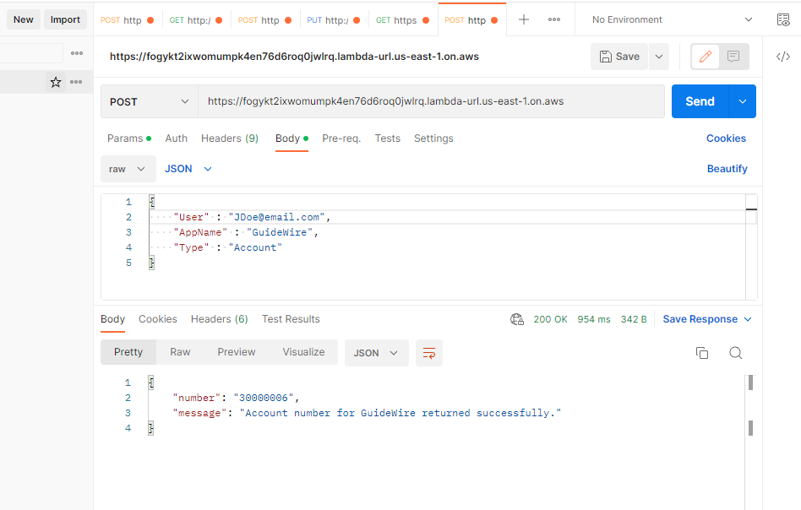

Assign new range for the applications as follow:

* Send PUT request with the following json parameters:

{

"StartRange": " 30000001",

"EndRange": " 80000000",

"UserRole": "Admin"

}

* The above request assigns the new range for all applications.

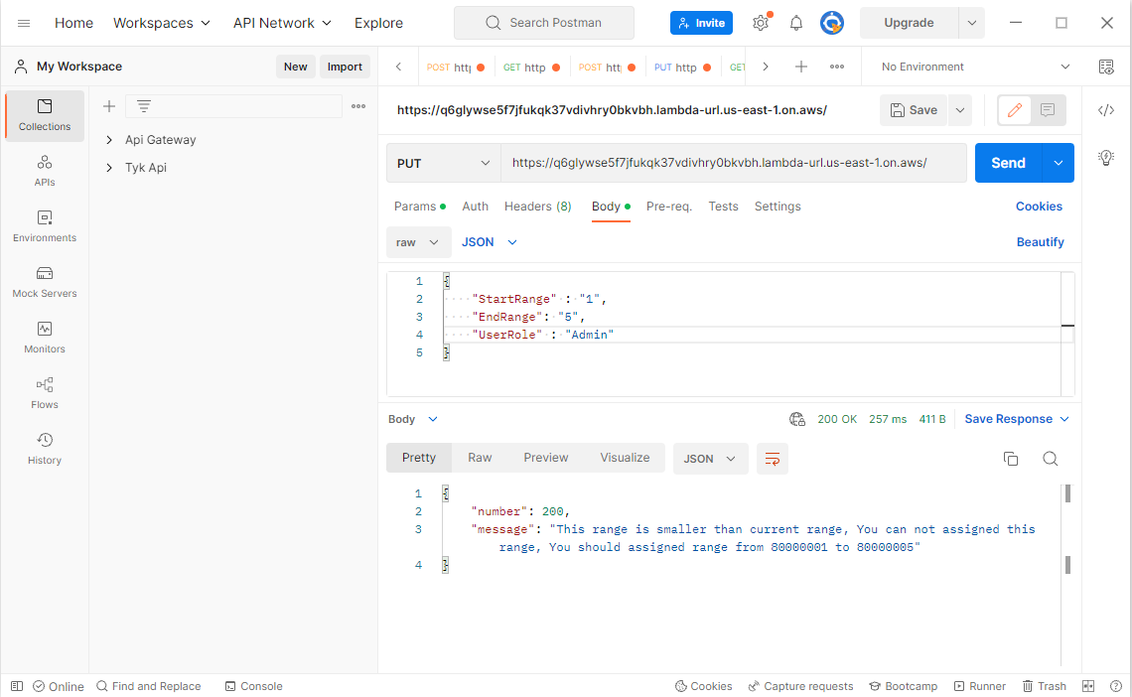

In case complete project is to be deleted, run the following command:

**$ terraform destroy**

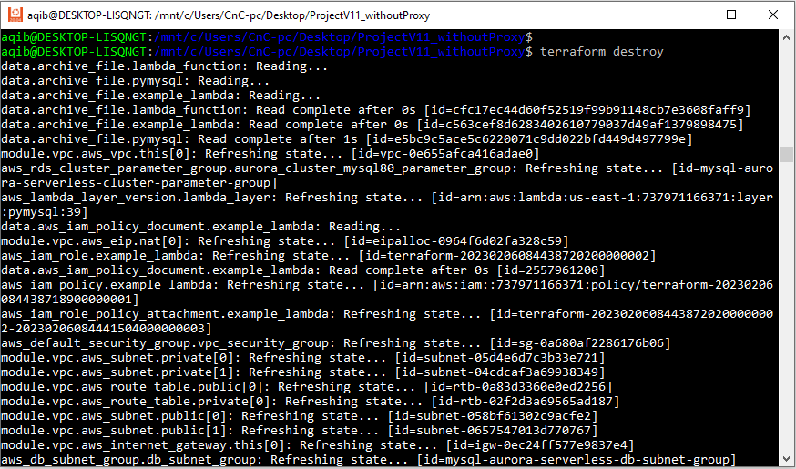

**Schema for RDS**

Lambda function creates following 2 tables in the RDS database:

1. SequenceRange
2. SequenceIds

### **SequenceRange**

Columns in the SequenceRange table are ( Id, StartRange, EndRange and Status ) and this table is used to store the starting point, ending point and status for all applications in the table.

### **SequenceIds**

Columns in the SequenceIds table are ( Id, AppName, Type, Date, Time and User ) and this table is used to generate a new Id and save application name, type of id, current date, time and user information in that table.